To find if there is a simpler set of factors that explains the data captured by brand imagery perception statements for Nordstrom? And Should Nordstrom be focusing on the brand imagery factors above or Brand Commitment and Likelihood to Purchase in order to increase the Likelihood of Recommendation?

Solution:
Here Brand Imagery (Q15_3) is the variable of interest and we observe there are some N/A so labelling them as missing values and changing the scale to Interval.

In the Analyze > Dimension Reduction > Factor Analysis with following settings

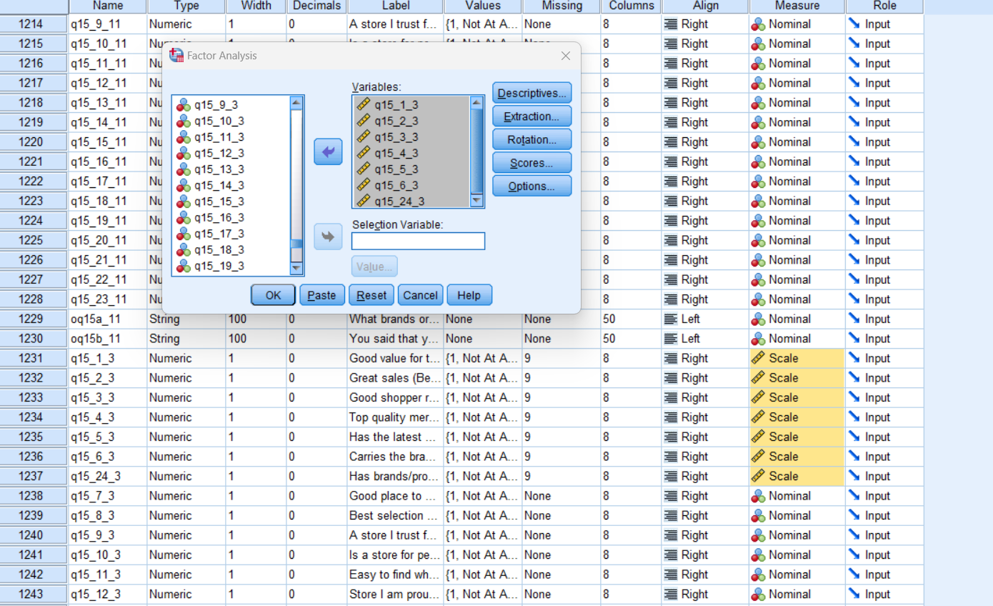

- Enabling thew KMO and Bartlett’s test of sphericity in Descriptives

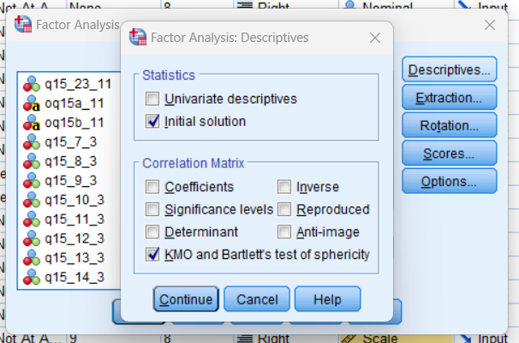

- Performing the Principal Component Analysis in Extraction and extract factors with eigen values greater than 1.
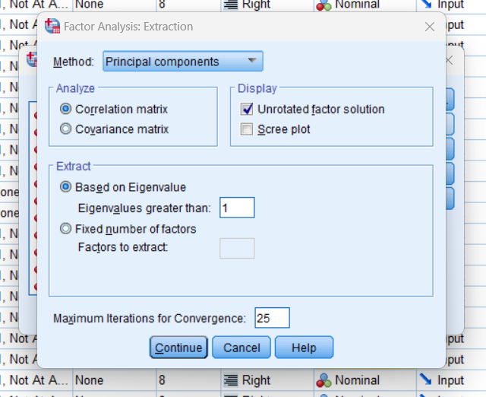

- Performing the Varimax method in Rotation

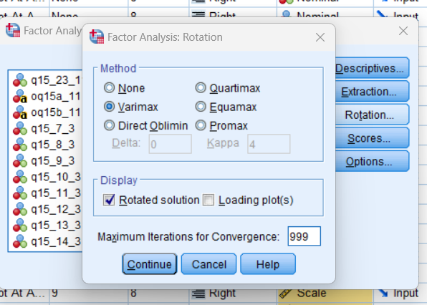

- Choose Regression as method of Factor scores

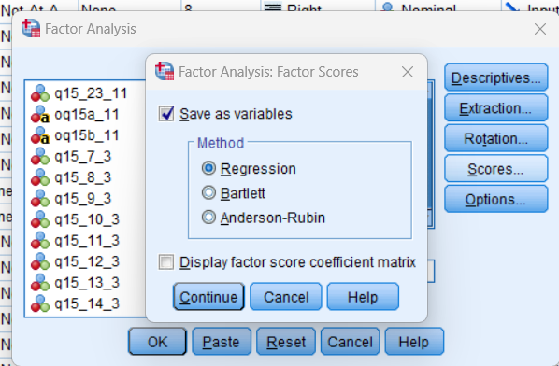

The results of the above test

We perform KMO where value is between 0.5 and 1 and bartlett’s test where the
sphericity is rejected with significance <0.001, we can perform factor analysis.

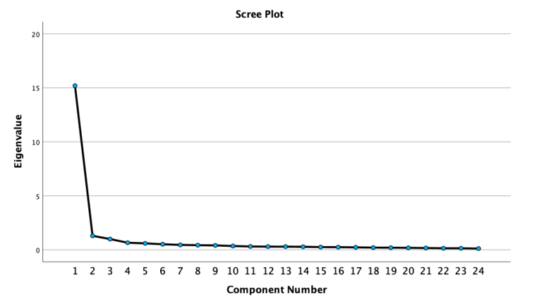

With the setting of eigen values > 1 we get the above output. But the third factor value
is 0.998 and close to 1 so we changed the setting to fix the number of factors to 3 and
got the next output.

So, we observe 3 factors for brand imagery perception statements for Nordstrom.

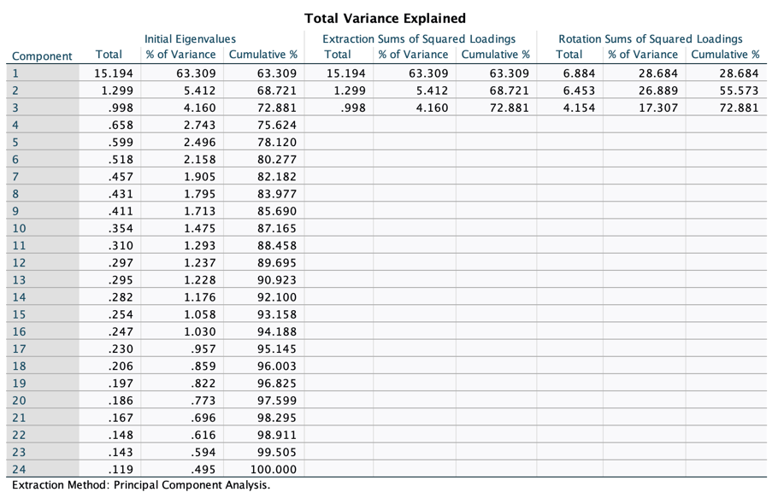

Based on the tables, factor 1 – has the latest styles, top quality merch, best selection of
brands, store I trust, carried the brands I want, stores I am proud of, has brands I want,
good place to shop for gifts, merch worth paying more.

Factor 2 – great sales, good reward program, good value for money, inspired me to try
new things, often discover new things to buy, helps express personal style, store for
people like me, fun shopping experience, innovative, easy to find.

Factor 3 - available Sales people, Warm and friendly sales people, Easy return,
Consistent experience, Convenient way to shop.

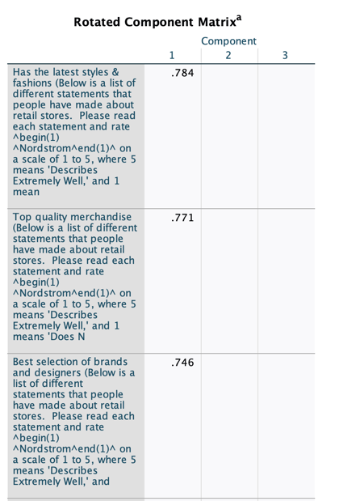

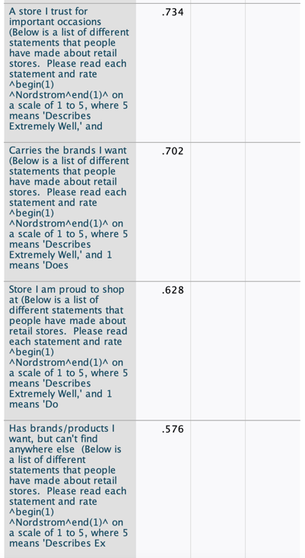

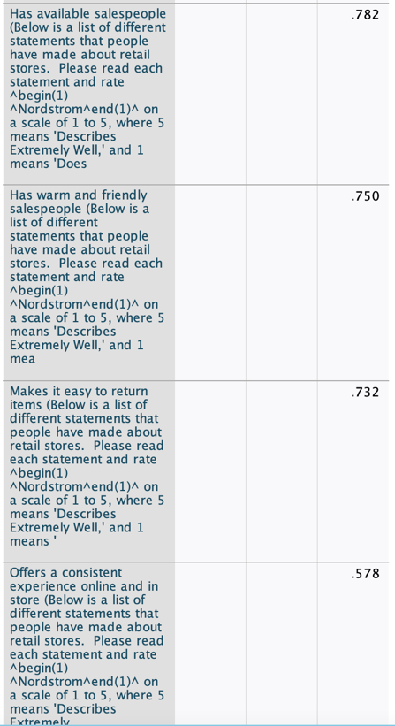
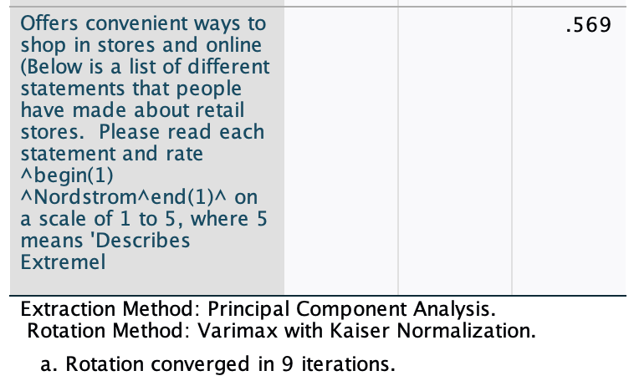

Now to find whether NordStorm should focus on brand imagery factors above or Brand Commitment and Likelihood to Purchase in order to increase the Likelihood of Recommendation

We will perform Mulitple linear regression on questions Brand Commitment (Q11_3), Likelihood to Purchase (Q12_3) and the 3 factors from previous question (Brand imagery) as independent variables and Likelihood of Recommendation (Q13_3) as dependent variable.

Null Hypothesis H₀: There is no linear relationship between Brand Commitment, Likelihood to Purchases and the 3 factors from Brand imagery related to Likelihood of Recommendation for NordStorm.

From Analyze > Regression > Linear

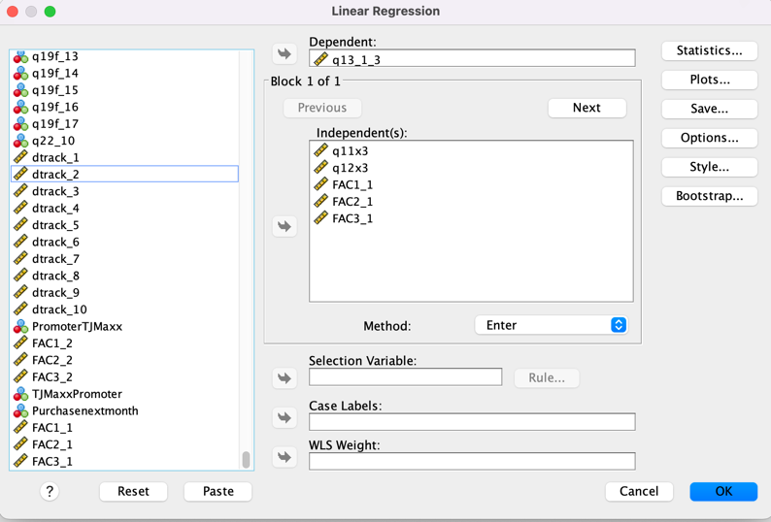

The result of the Multiple Linear Regression is as follows:

The independent variables are explaining 49.5%of the variance in the dependent variable from the adjusted r square. The model is significant from the ANOVA table.

Multiple Correlation R = 0.708 -: It tells us there is high positive correlation Brand Commitment, Likelihood to Purchases and the 3 factors from Brand imagery related to Likelihood of Recommendation for Nordstrom.

From above table, we can say that A statistically significant proportion of the variability in Likelihood of Recommendation for Nordstrom can be attributed to the regression model (since p<0.01 for ANOVA test).

From the above we can conclude that,
Nordstrom’s Likelihood of Recommendation = 8.883 +(-0.354*Nordstrom Commitment) +(0.706* factor 1) +(0.588*factor 2) +(0.585*factor 3)
Except the likelihood to purchase, all other factors are significant.
We can reject the null hypothesis and can represent the relation using the above equation and can say that if no other value changes, a unit change increase in Nordstrom Commitment will decrease the Nordstrom’s Likelihood of Recommendation by 0.354.

Nordstrom must focus more on the factor 1 (Std. Beta coeff: 0.382) followed by factor 2 (Std. Beta coeff: 0.319), factor 3 (Std. Beta coeff: 0.316) and then finally brand commitment to Impact likelihood to recommendation (Std. Beta coeff: -0.203).

